**Digital Design and Computer Organization Laboratory**

**UE19CS206**

**3rd Semester, Academic Year 2020-21**

Date: 18/10/20

|  |  |  |
| --- | --- | --- |
| Name : Achyut Jagini | SRN : PES2UG19CS013 | Section : A |

Experiment Number: 6 Week # : 6

**Title of the Program:**

16 Bit Program Counter

**Aim of the Program:**

To Design and Implementation of a 16 bit Program Counter

**Code (pc.v)**

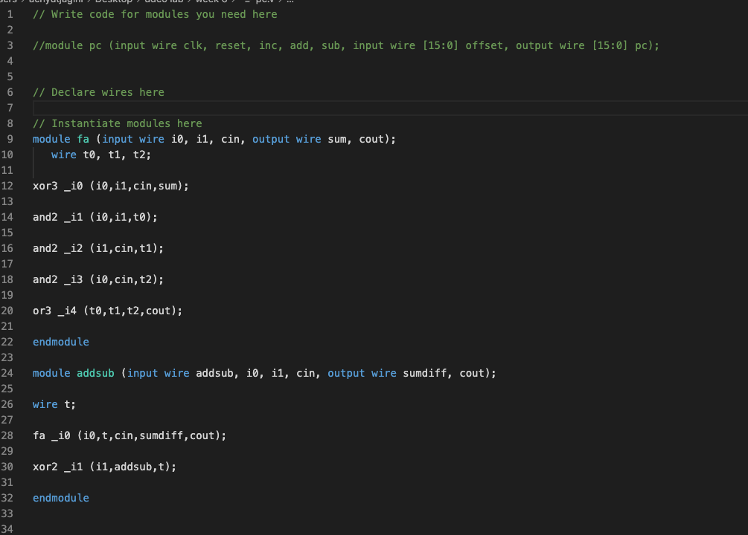

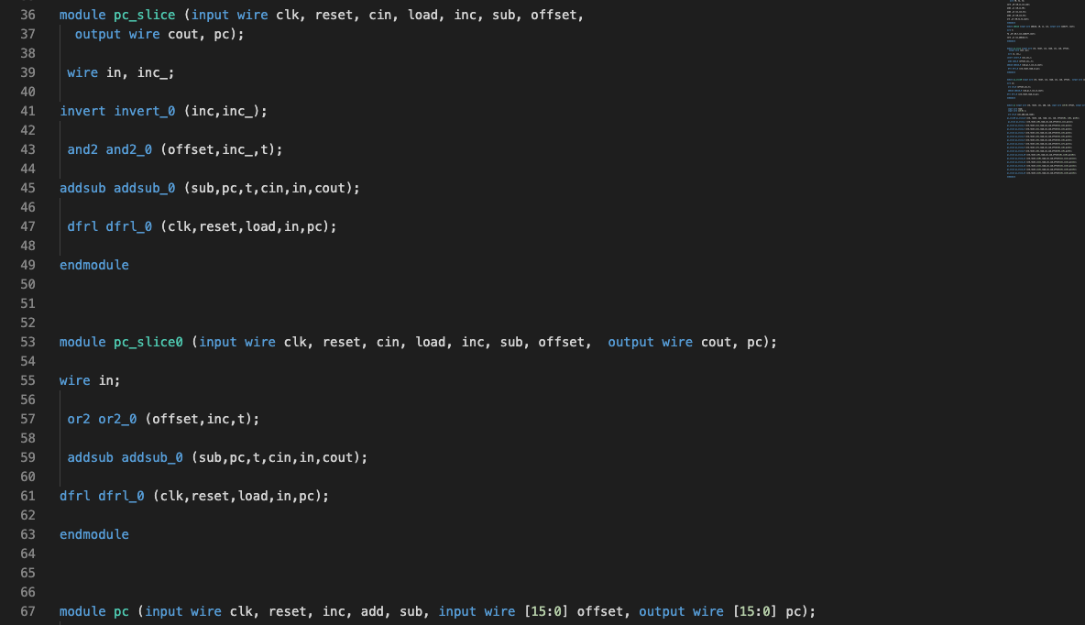

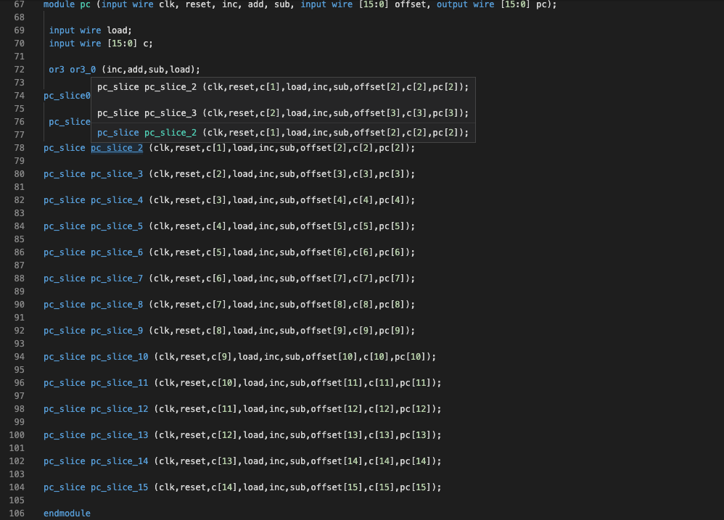

**TABLE**

|  |  |  |  |  |  |
| --- | --- | --- | --- | --- | --- |
|  | **inc** | **add** | **sub** | **offset**  **[15:0]** | **output** |
|  | **Bit 18** | **Bit 17** | **Bit 16** | **Bit 15 to Bit0** | **pc[15:0]** |
| **CASE 1** | **1** | **0** | **0** | **XXXX** | **0001** |
| **CASE 2** | **0** | **1** | **0** | **00A5** | **00A6** |
| **CASE 3** | **0** | **0** | **0** | **XXXX** | **00A6** |
| **CASE 4** | **1** | **0** | **0** | **XXXX** | **00A7** |
| **CASE 5** | **0** | **0** | **1** | **0014** | **Pc-offset**  **=00A7-001**  **=0093** |

**Output waveform**

**SCREENSHOT1**

**CASE1 :PC Increment Operation with no offset**

|  |  |  |  |  |  |
| --- | --- | --- | --- | --- | --- |
|  | **inc** | **add** | **sub** | **offset**  **[15:0]** | **output** |
|  | **Bit 18** | **Bit 17** | **Bit 16** | **Bit 15 to Bit0** | **pc[15:0]** |
| **CASE 1** | **1** | **0** | **0** | **XXXX** | **0001** |

**SCREENSHOT2**

**CASE 2 :Add Offset to PC**

|  |  |  |  |  |  |
| --- | --- | --- | --- | --- | --- |
|  | **inc** | **add** | **sub** | **offset**  **[15:0]** | **output** |
|  | **Bit 18** | **Bit 17** | **Bit 16** | **Bit 15 to Bit0** | **pc[15:0]** |
| **CASE 2** | **0** | **1** | **0** | **00A5** | **00A6** |

**SCREENSHOT 3**

**CASE 3 :No change in PC**

|  |  |  |  |  |  |
| --- | --- | --- | --- | --- | --- |
|  | **inc** | **add** | **sub** | **offset**  **[15:0]** | **output** |
|  | **Bit 18** | **Bit 17** | **Bit 16** | **Bit 15 to Bit0** | **pc[15:0]** |
| **CASE 3** | **0** | **0** | **0** | **XXXX** | **00A6** |

**SCREENSHOT 4**

**CASE 4 :Auto increment current value of PC**

|  |  |  |  |  |  |
| --- | --- | --- | --- | --- | --- |
|  | **inc** | **add** | **sub** | **offset**  **[15:0]** | **output** |
|  | **Bit 18** | **Bit 17** | **Bit 16** | **Bit 15 to Bit0** | **pc[15:0]** |
| **CASE 4** | **1** | **0** | **0** | **XXXX** | **00A7** |

**SCREENSHOT 5**

**CASE 5 :Subtract offset contents from PC**

|  |  |  |  |  |  |
| --- | --- | --- | --- | --- | --- |
|  | **inc** | **add** | **sub** | **offset**  **[15:0]** | **output** |
|  | **Bit 18** | **Bit 17** | **Bit 16** | **Bit 15 to Bit0** | **pc[15:0]** |
| **CASE 5** | **0** | **0** | **1** | **0014** | **Pc-offset**  **=00A7-001**  **=0093** |

